Batch: A1 Roll No.: 16010123012
Experiment No.: AWS 2
Grade: AA / AB / BB / BC / CC / CD /DD

Title: AWS Resource Setup Using Amazon S3
Objective: To access the AWS Management Console, create and configure an Amazon S3 bucket, enable security features like encryption and versioning, and upload datasets for storage.
Expected Outcome of Experiment:
CO | Outcome
Create and configure an S3 bucket
Understand cloud storage concepts using AWS

Books/ Journals/ Websites referred:
https://kjssecloudlab.somaiya.edu/lab-catalogue/CloudComputing_Lab2
Abstract:
This experiment focuses on setting up cloud storage using Amazon S3. It involves creating a secure storage bucket, configuring encryption and access settings, enabling version control, and uploading datasets. The lab demonstrates how cloud storage can be efficiently used for managing and maintaining datasets, especially in data-driven applications.
Related Theory:
Amazon S3 (Simple Storage Service) is a scalable object storage service provided by AWS. It allows users to store and retrieve data from anywhere on the internet. S3 stores data in buckets, which act as containers for objects (files).
Key features include:
- Scalability: Automatically scales storage as needed
- Durability: Provides 99.99% data durability
- Security: Supports encryption and access control mechanisms
- Accessibility: Data can be accessed globally via the internet
Implementation Details:
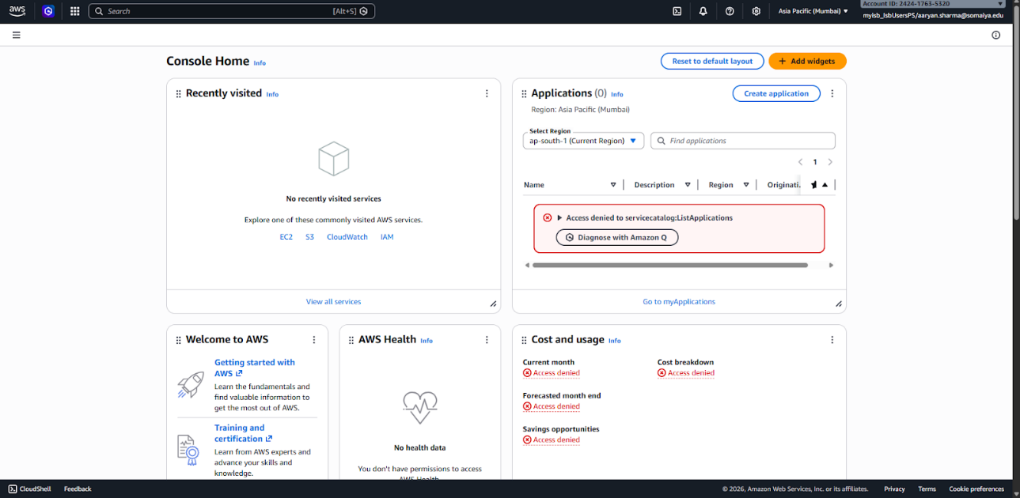
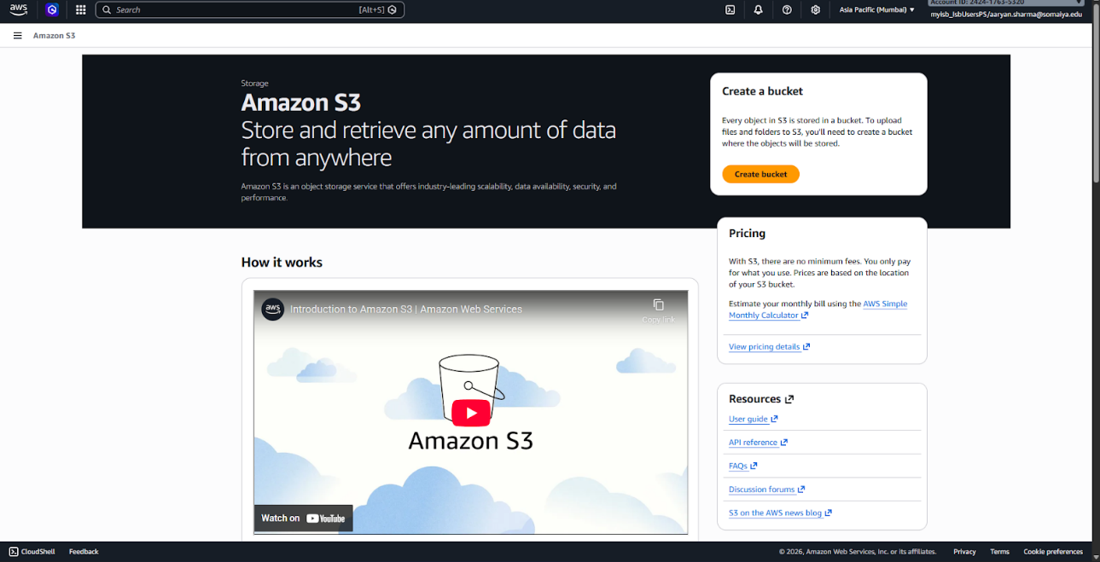
AWS Management Console showing selection of Amazon S3 service
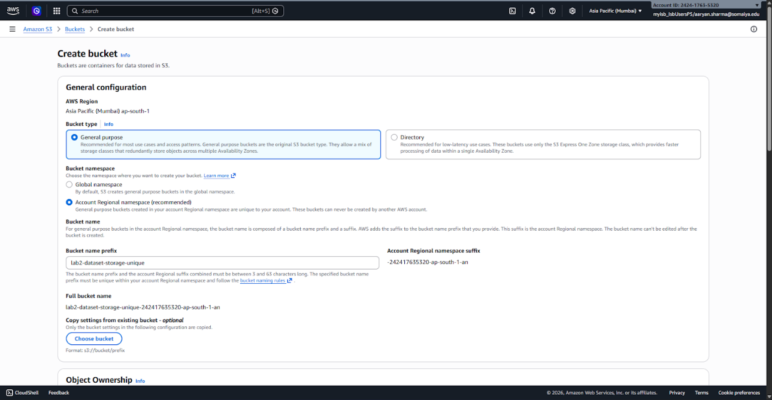
Creating a new S3 bucket
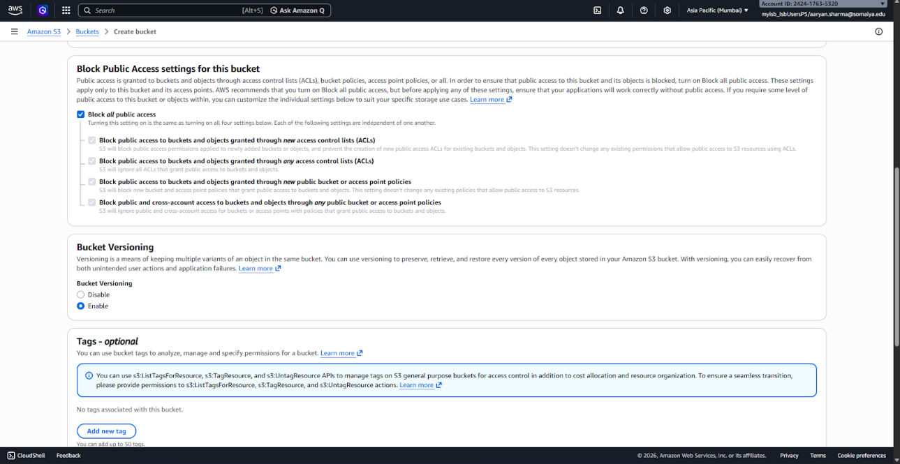
Configuring Public Access and Enabling Bucket Versioning
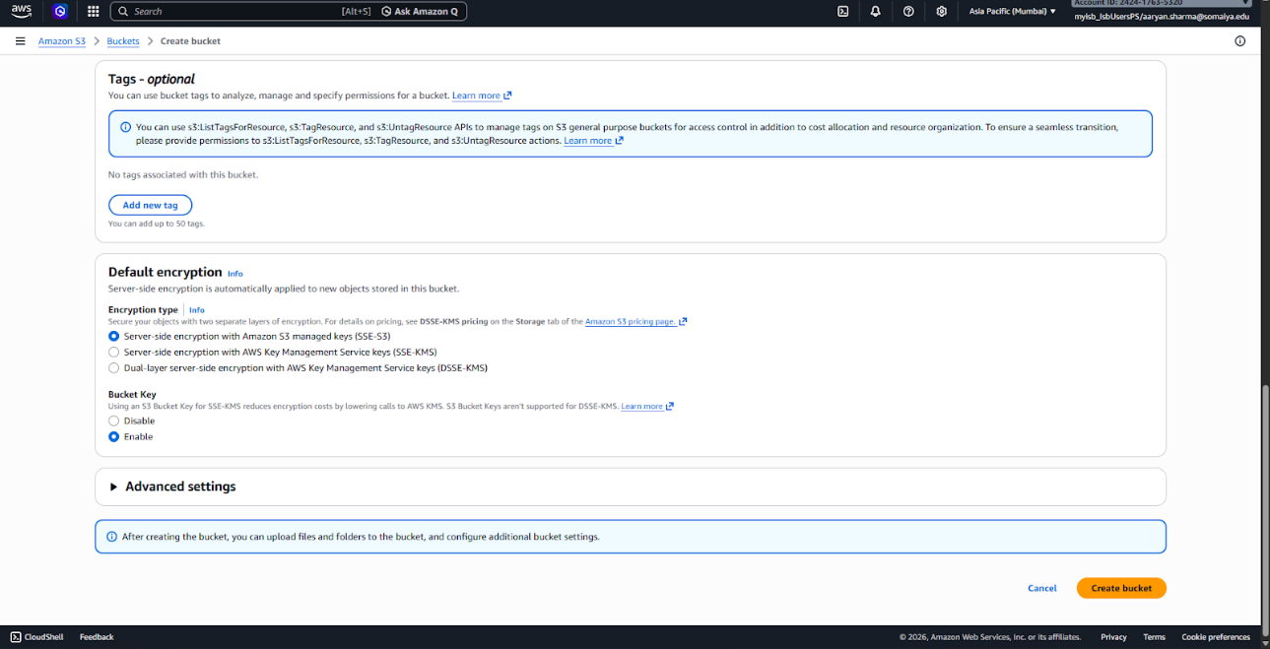
Configuring server-side encryption
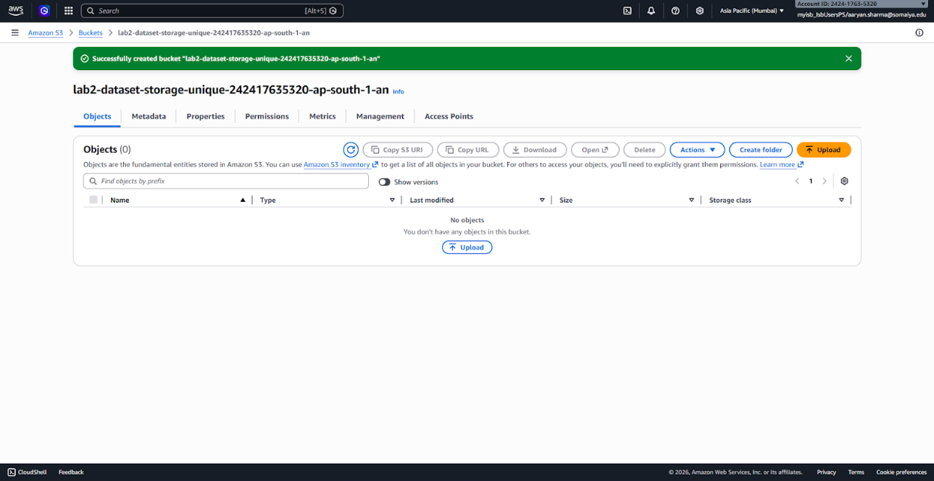Successfully created S3 bucket

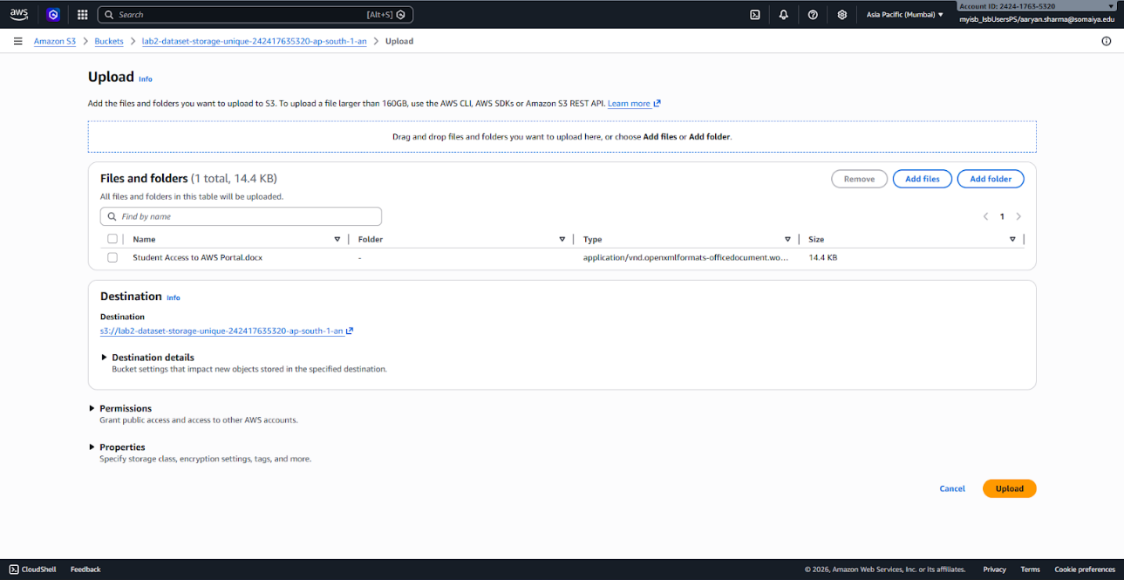Uploading files
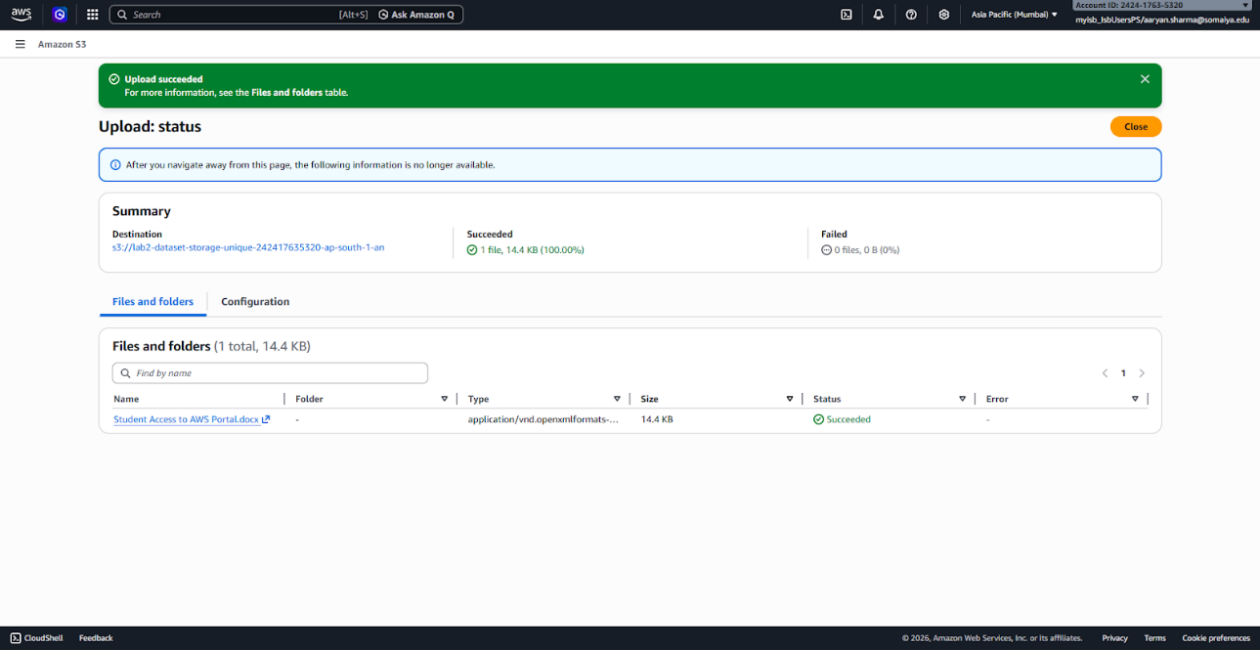Files successfully uploaded and stored
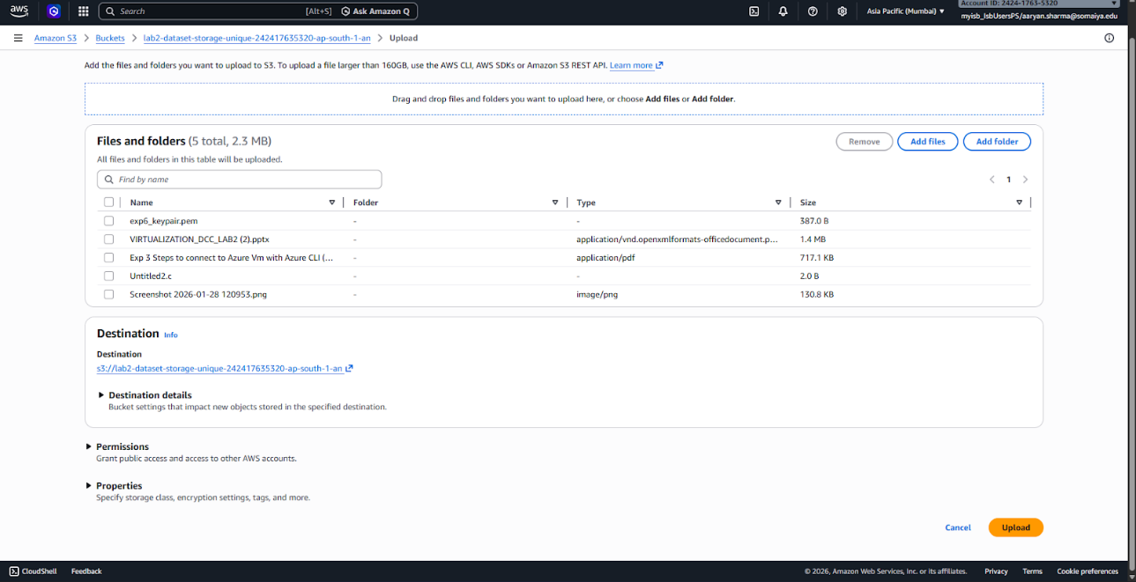
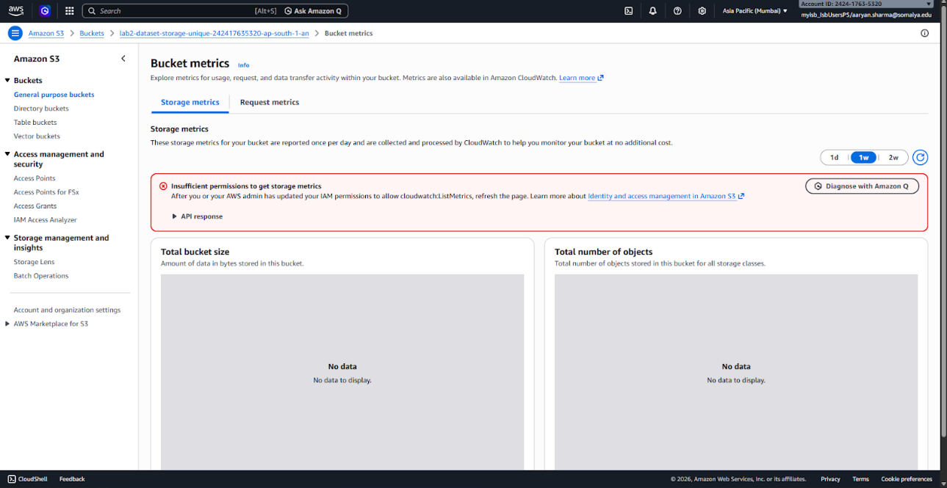
Verifying storage usage and object details
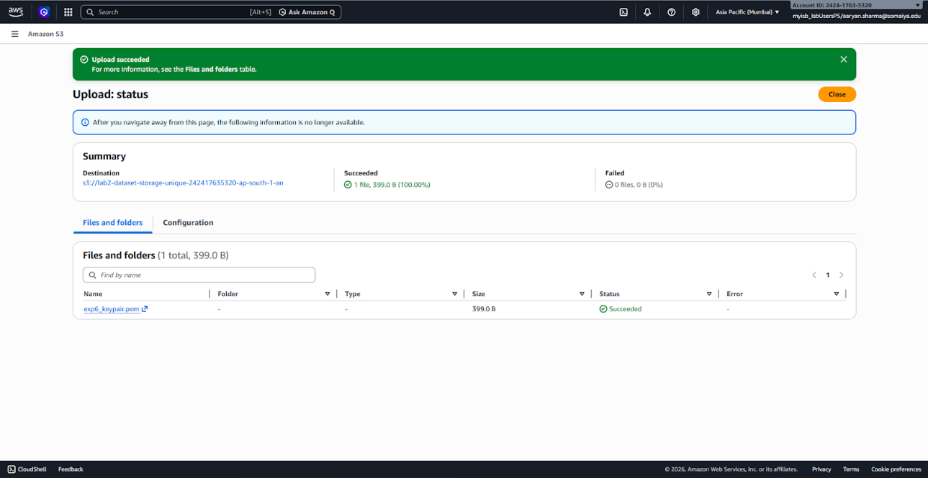
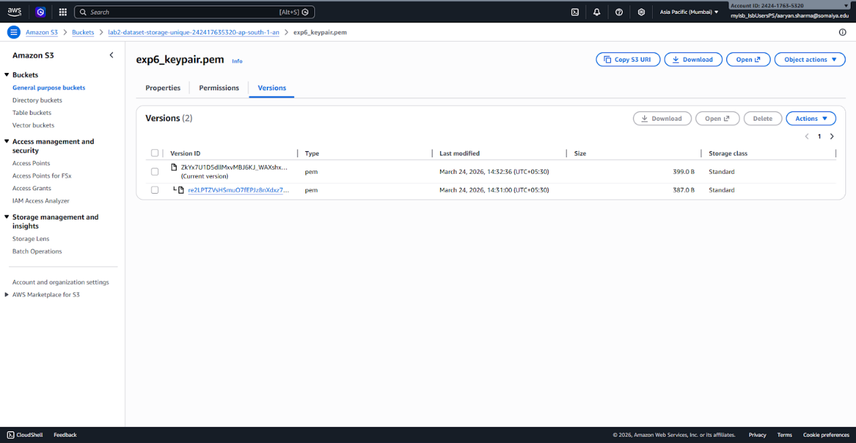Demonstration of versioning by storing multiple versions of a file
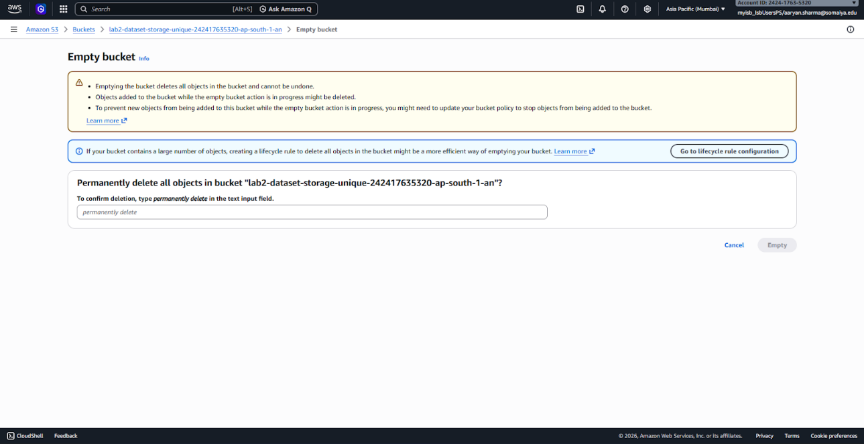
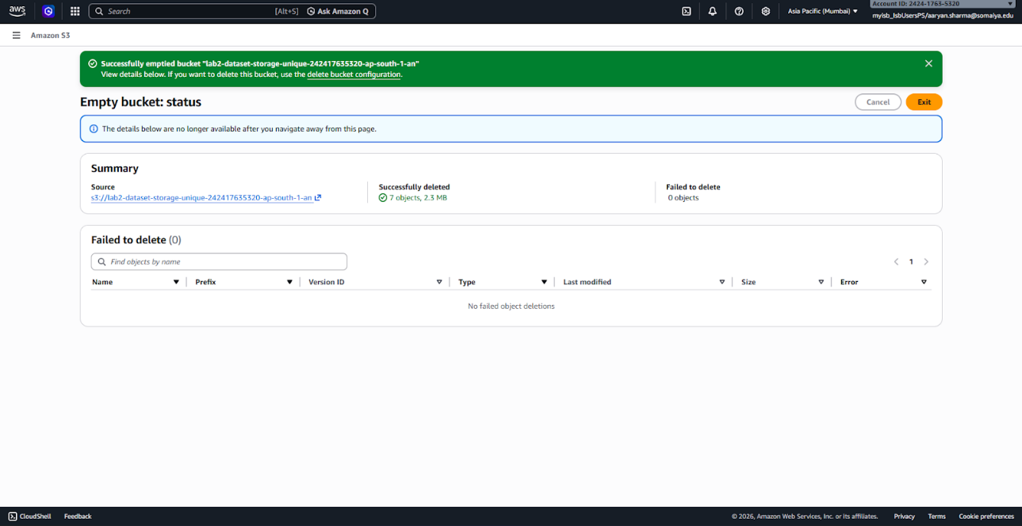Emptying the S3 bucket by deleting all stored objects

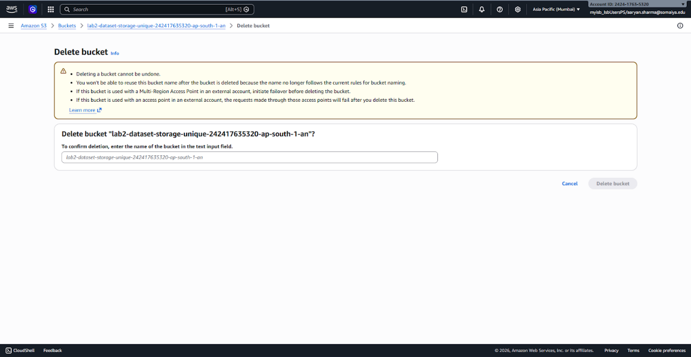
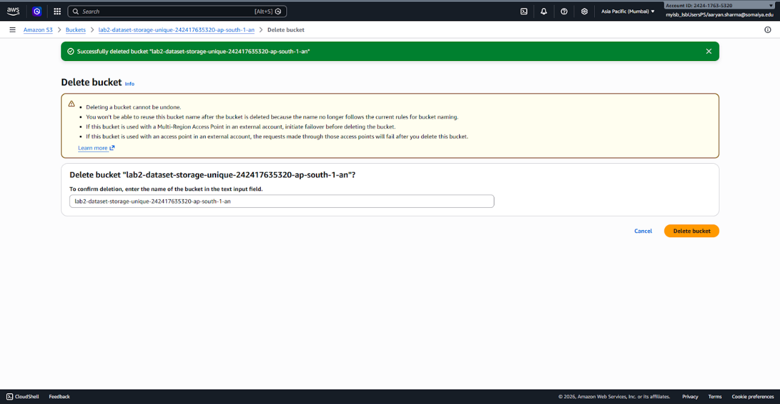Successfully deleting the S3 bucket from AWS console
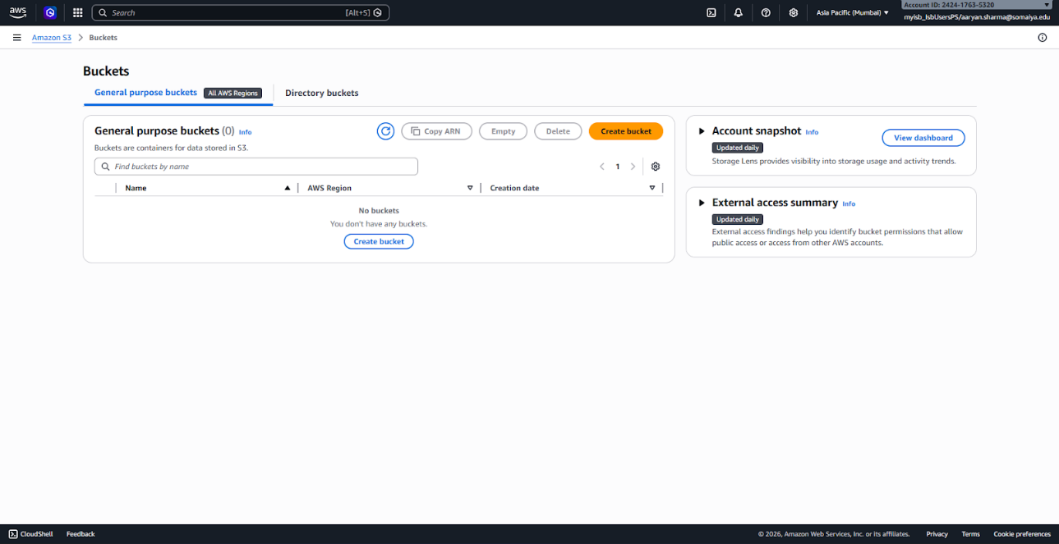
Result: The S3 bucket was successfully created, configured, and used for storing and managing data in the cloud.
Conclusion:
Amazon S3 was successfully used to create and manage cloud storage resources. A new S3 bucket was created and configured with public access control, encryption, and versioning. Files were uploaded to the bucket and their storage was verified, demonstrating efficient data storage and retrieval in the cloud. Versioning functionality was tested to understand data recovery and change tracking. Finally, the bucket was emptied and deleted, illustrating complete lifecycle management of cloud storage resources. This experiment provided practical understanding of object storage and highlighted the scalability, security, and durability features of Amazon S3 in cloud computing.

